Tonal

**Technical Take-home**

# Applicant: [Edima Udo]

## Goals

The goal of this technical take-home includes:

1. use of a web-based business intelligence tool
2. investigating a new dataset with SQL
3. communication of your results via written and visual replies

## Context

As part of our work as analysts, we're often required to pick up new tools and generate insights quickly. As part of our interview process, we'd like you to try (what may be) a new tool to answer some business questions. Mode Analytics is a business intelligence and visualization to be used in this take-home. ***Instructions to create a new Mode Analytics account can be found at the end of this document.*** Additionally, the schema containing the relevant tables are included as part of Mode's Public warehouse.

## Instructions

**Please work in and edit this document directly to answer all questions and provide access to any linked documentation.**

We anticipate this exercise to take approx 2-3 hours. Email any questions and your final version to [michelle@tonal.com](mailto:michelle@tonal.com).

To answer each question, we ask that you include two things:

* a brief answer to the questions; please clearly state your assumptions and the logic of your solution
* your SQL query/code; you may include an external link (Google Doc or Mode Report) to reference your source code
* You may also create a notebook in Mode Analytics to complete this exercise if you would like to, but please include SQL code for every answer
* Keep in mind code format, comments etc. – make the code as legible as possible

Yammer is a social network for communicating with coworkers. Individuals share documents, updates, and ideas by posting them in groups. Please use the Yammer data to answer the following questions. The four tables available in mode are:

tutorial.yammer_emails

tutorial.yammer_events

tutorial.yammer_experiments

tutorial.yammer_users

## Part 1

Please complete the following questions based upon the data referenced above. This section focuses on your coding skills.

Before you begin, draw out a simple database schema diagram on how you think these datasets are linked together and share this in your answer key.

1. How many users are in the yammer dataset? What percentage of users are active?
2. Which acquisition month drove the highest # of active users? And how many users in that month?
3. What percentage of active users have opened emails (any emails) from Yammer?
4. Provide the 5 most active users logging in to Yammer from the United States for company_id 1, 2 & 4 (total of 15 user_ids).
5. For the Weekly Digest emails, which weeks had the highest email open rate and click through rate and what were the rates during those weeks?
6. For the companies which have more than 100 English users, what is the percentage of users who have both ‘liked’ a message AND done a ‘search autocomplete’ event for each company?

## Part 2

This section focuses on your ability to do an analysis.

1. Looking at all of the yammer datasets, what conclusions can you draw about the types of users who have the highest engagements with Yammer?
2. Looking at the yammer ‘publisher update’ experiment, would you say that the experiment was successful? Did it work better in some locations vs. others? Would you recommend rolling it out?

Support your answer with data and/or visualizations.

*While you may use Excel or non-SQL tools to answer this question, we prefer you use Mode Dashboards/Reports and be prepared to present them to us.*

**PLEASE NOTE:** Some free Mode accounts no longer support “public” views or they have made it harder to share than in the past. As such, if you can’t share your dashboard then please export your dashboard to PDF and email to us or attach a link to it below.

## Appendix: How to set up a free Mode Account

1. Visit <https://modeanalytics.com/>
2. Enter your email to sign up for a free account for Mode Studio, and enter your details on the following page.

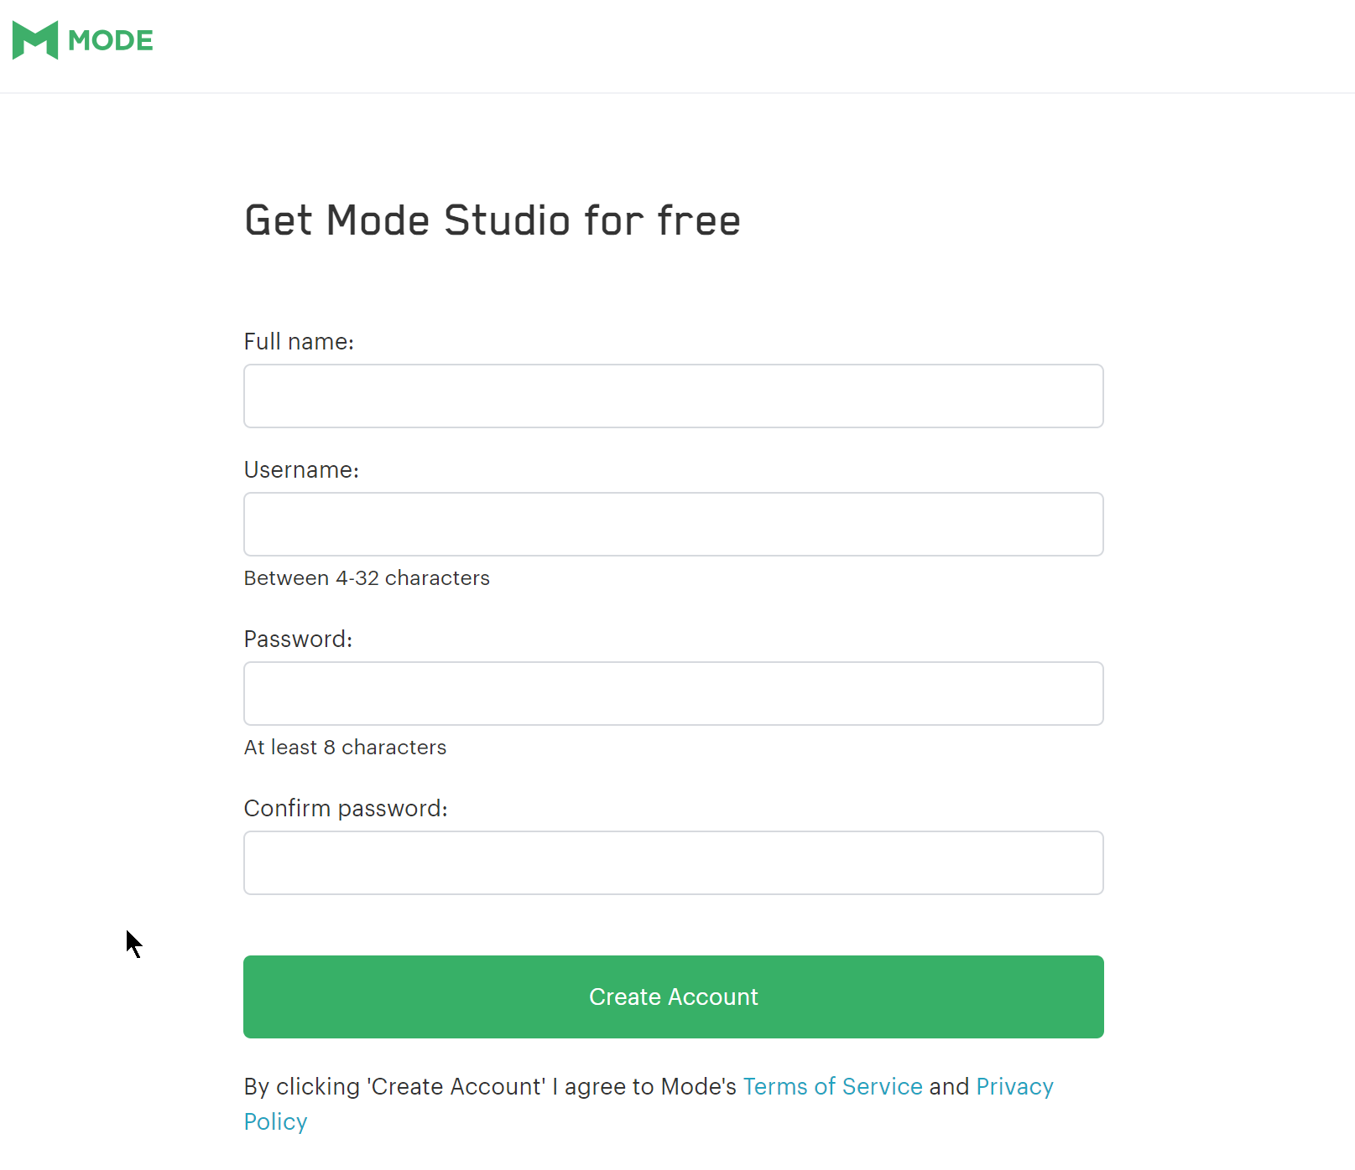

1. Click "Start using Mode with Sample data" to open the SQL editor.

4. Enter the following code to confirm you have access to the data:

select * from tutorial.yammer_emails

## Your Answers

Use the space below - **formatted as you see fit** - to answer the test questions.

**Part 1**

1. **Design a simple database schema diagram on how you think these datasets are linked together**

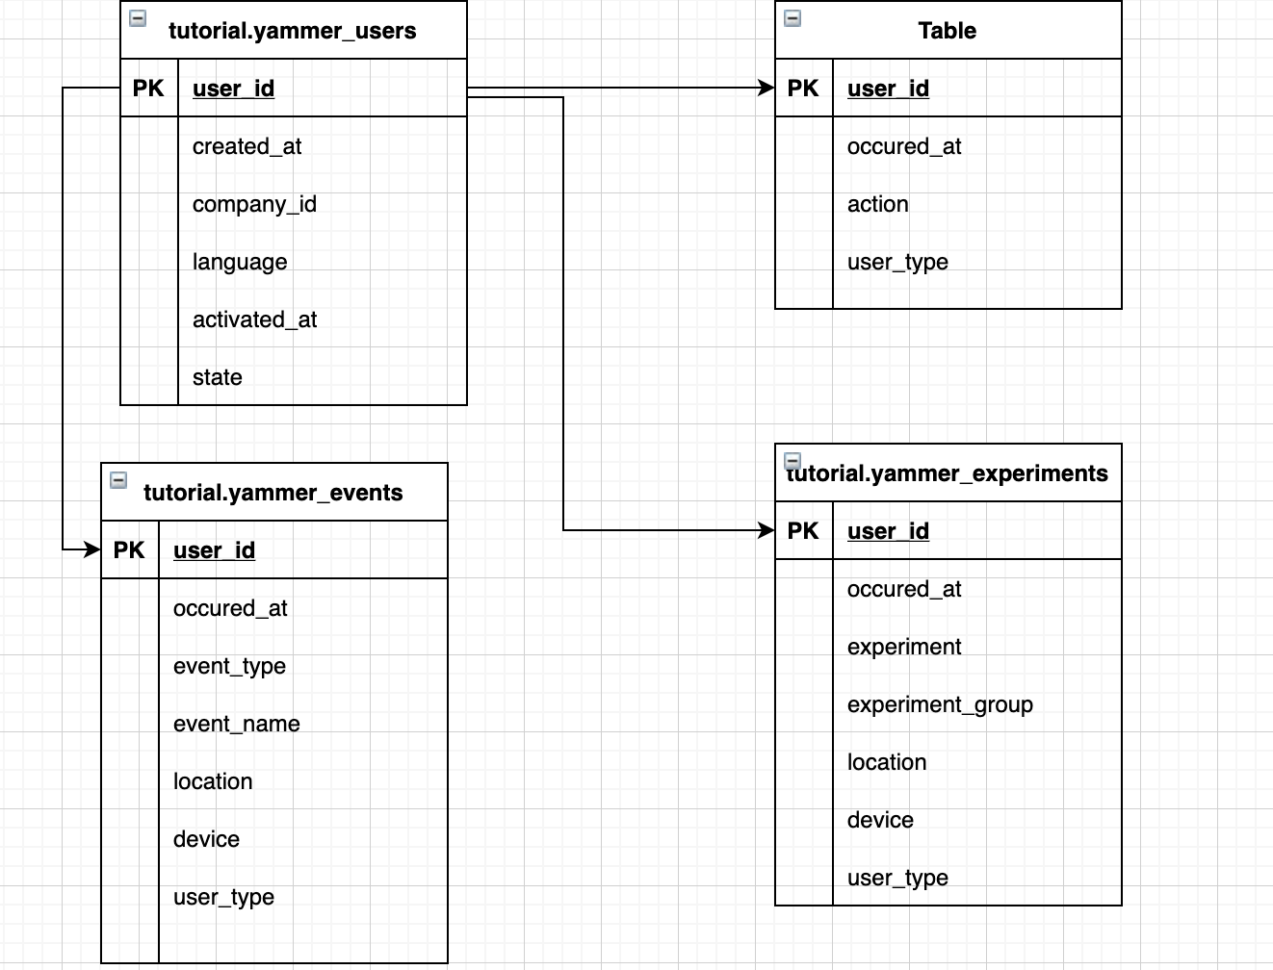

1. **How many users are in the yammer dataset? What percentage of users are active?**

The number of users in the dataset is 19066. The logic is to use a count of user id.

SQL Query

select count(distinct user_id) from tutorial.yammer_users

The percentage of active users are: 49.2%. The logic is to use a case statement and average.

SQL Query

Select AVG(CASE WHEN state = 'active' THEN 1.0 ELSE 0 END)

From tutorial.yammer_users

1. **Which acquisition month drove the highest # of active users? And how many users in that month?**

Looking at Year and month

The acquisition month that drove the highest # of active user was: August

And the number of users are: 1990. The logic behind this is to get date level information using built in functions and a count using case statement. The same applies when looking at month only.

SQL Query

Select DATE_PART('year',created_at) as YearInfo , DATE_PART('month',created_at) as MonthInfo ,COUNT(CASE WHEN state = 'active' THEN 1.0 ELSE 0 END) AS activeUsers

from tutorial.yammer_users

group by DATE_PART('year',created_at), DATE_PART('month',created_at)

order by 3 DESC

Looking at month only

The acquisition month that drove the highest # of active user was: August

And the number of users are: 2626

SQL Query

Select DATE_PART('month',created_at) as MonthInfo ,COUNT(CASE WHEN state = 'active' THEN 1.0 ELSE 0 END) AS activeUsers

from tutorial.yammer_users

group by DATE_PART('month',created_at)

order by 2 DESC

1. **What percentage of active users have opened emails (any emails) from Yammer?**

Assumption: opened email means open email and email click through

The percentage of active users that have open emails from yammer are: 32.6%. The logic behind this is to use case and average to get the percentage.

SQL Query

Select AVG(CASE WHEN tu.state = 'active' and te.action in ('email_open', 'email_clickthrough') THEN 1.0 ELSE 0 END) as ActiveEmailCount

From tutorial.yammer_users tu inner join tutorial.yammer_emails as te on tu.user_id = te.user_id

1. **Provide the 5 most active users logging in to Yammer from the United States for company_id 1, 2 & 4 (total of 15 user_ids).**

Assumption logged in only factors in the event name login.

Output

|  |  |  |
| --- | --- | --- |
| user_id | company_id | activecount |
| 2940 | 1 | 39 |
| 2990 | 1 | 27 |
| 9479 | 1 | 24 |
| 5134 | 1 | 22 |
| 14018 | 1 | 19 |
| 10067 | 2 | 35 |
| 4442 | 2 | 24 |
| 4248 | 2 | 18 |
| 5168 | 2 | 18 |
| 1650 | 2 | 16 |
| 2474 | 4 | 22 |
| 6372 | 4 | 20 |
| 12937 | 4 | 17 |
| 12178 | 4 | 9 |
| 13671 | 4 | 5 |

SQL Query

(select tu.user_id, company_id, count(*) as activeCount

from tutorial.yammer_users tu inner join tutorial.yammer_events te on tu.user_id = te.user_id

where tu.company_id = 1

and te.location = 'United States'

and tu.state = 'active'

and te.event_name = 'login'

group by tu.user_id, company_id

order by 3 DESC

LIMIT 5)

union

(select tu.user_id, company_id, count(*) as activeCount

from tutorial.yammer_users tu inner join tutorial.yammer_events te on tu.user_id = te.user_id

where tu.company_id = 2

and te.location = 'United States'

and tu.state = 'active'

and te.event_name = 'login'

group by tu.user_id, company_id

order by 3 DESC

limit 5)

UNION

(select tu.user_id, company_id, count(*) as activeCount

from tutorial.yammer_users tu inner join tutorial.yammer_events te on tu.user_id = te.user_id

where tu.company_id = 4

and te.location = 'United States'

and tu.state = 'active'

and te.event_name = 'login'

group by tu.user_id, company_id

order by 3 DESC

limit 5)

ORDER BY company_id ASC, activeCount DESC

1. **For the Weekly Digest emails, which weeks had the highest email open rate and click through rate and what were the rates during those weeks?**

Week with the highest click through rate is week 18 with 12.2%. The logic behind this is to arrange the information by week and get the weekly rate using case and average plus built in date functionality.

SQL Query

select DATE_PART('week',te.occurred_at) as WeekInfo,

AVG(CASE WHEN te.action = 'email_clickthrough' THEN 1.0 ELSE 0 END) as emailClickThrough

From tutorial.yammer_emails as te

group by 1

order by 2 DESC

limit 5

Week with the highest email open rate is week 35 with 23.95%

select DATE_PART('week',te.occurred_at) as WeekInfo,

AVG(CASE WHEN te.action = 'email_open' THEN 1.0 ELSE 0 END) as emailOpenRate

From tutorial.yammer_emails as te

group by 1

order by 2 DESC

limit 5

1. **For the companies which have more than 100 English users, what is the percentage of users who have both ‘liked’ a message AND done a ‘search autocomplete’ event for each company?**

The percentage is 22.85%. The logic behind this is to get the percentage of user. It involves using a sub query and case statement.

SQL Query

select AVG(CASE WHEN te.event_name in ('like_message','search_autocomplete') THEN 1.0 ELSE 0 END) as englishSearch

From tutorial.yammer_users as tu inner join tutorial.yammer_events as te on tu.user_id = te.user_id

where tu.company_id in (select tu.company_id

From tutorial.yammer_users as tu

where tu.language = 'english'

group by 1

having count(*) > 100)

## Part 2

1. Looking at all of the yammer datasets, what conclusions can you draw about the types of users who have the highest engagements with Yammer?
2. Looking at the yammer ‘publisher update’ experiment, would you say that the experiment was successful? Did it work better in some locations vs. others? Would you recommend rolling it out?